**CP Club 365 Days Challenge**

**Programming language – C++**

**Problem Statement**

<https://www.codechef.com/DSAPREP_01/problems/EMPR>

**Your Code**:

// 0x80Day of 0x365Days challenge

// VEDANT BHARAD

// 5-1-2023

#include <bits/stdc++.h>

using namespace std;

int main() {

    // your code goes here

    int t;

    cin >> t;

    while(t--)

    {

        int x,y,z;

        long double p,ans;

        cin >> p >> x >> y >> z;

        if(z == 1)

        {

            ans = p + (p*y)/100;

        }

        else

        {

            ans = p - (p*x)/100;

        }

        cout << fixed << setprecision(5) << ans << endl;

    }

    return 0;

}

**Output (Screen Shot)**:

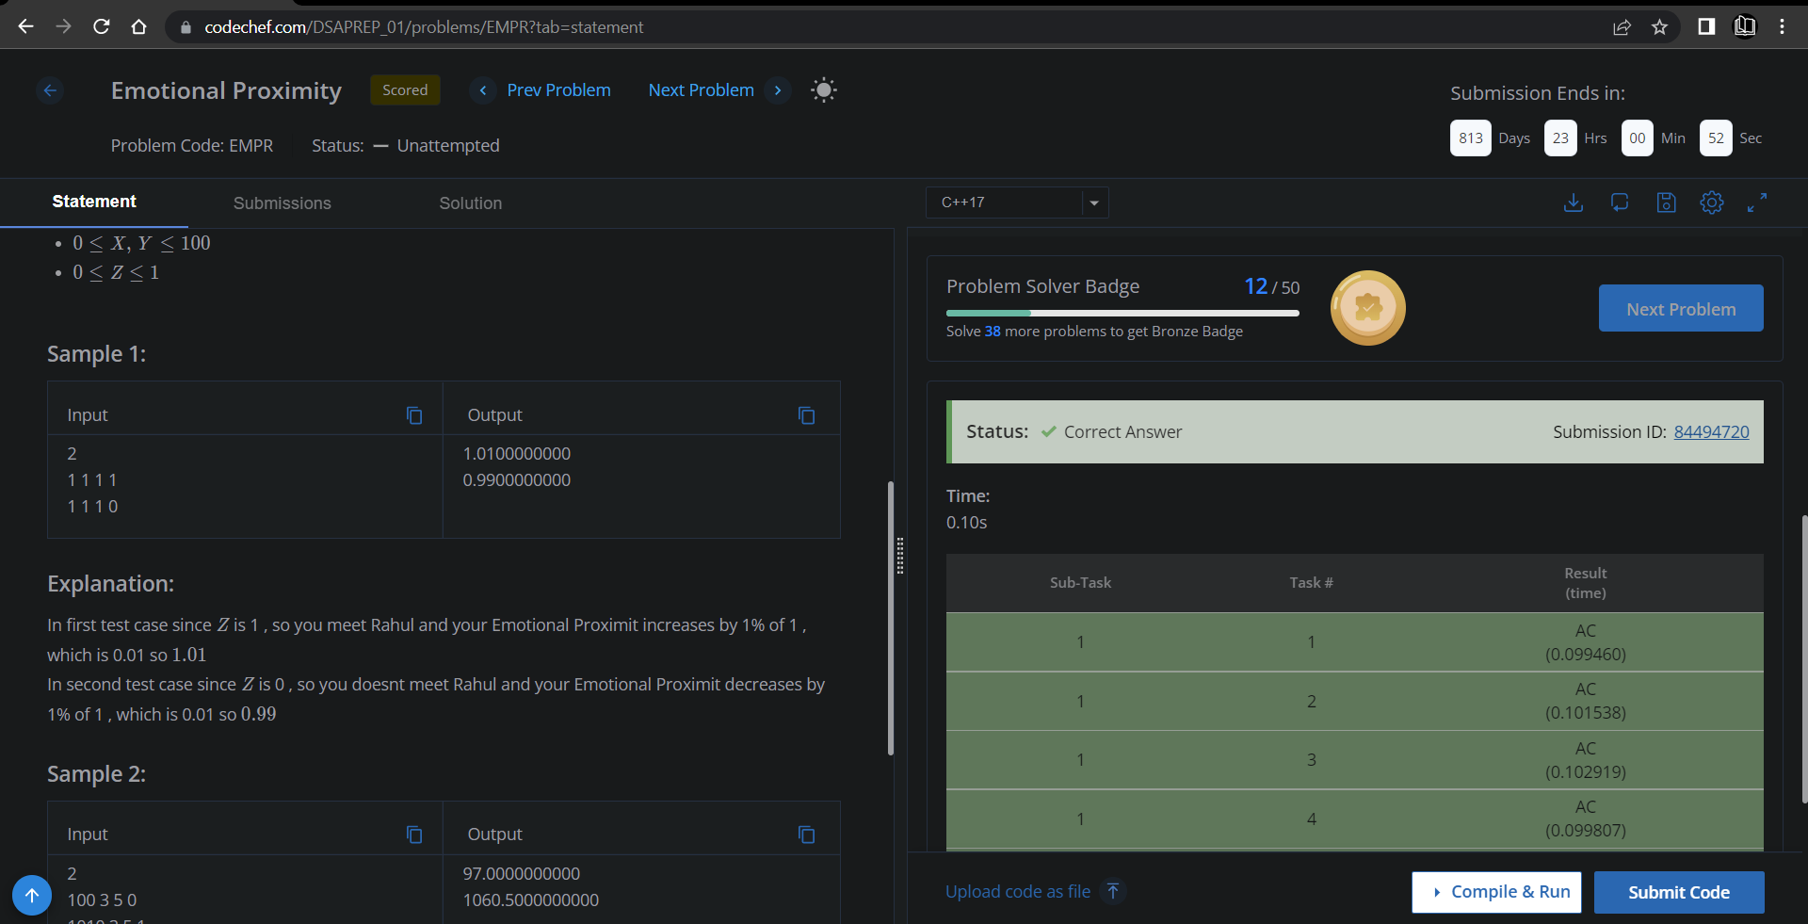

**Understanding about problem:**

* In this task there is P,X,Y,Z as a input.
* I need to return (p + (p*y)/100) if Z is 1 else (p - (p*y)/100).

Note: If you can't understand the problem, feel free to contact us and we'll help you. Please don't copy and paste from anywhere.

ALL THE BEST

Team CP Club